Adding a New Class

The Consumer death is the screen where you record the death of a consumer. When a consumer dies you must discharge them from their programs and end date any open address, contacts, or service plans that they might have open. Because of the possibility all of these dates being different the actual date of death and manner of death is stored on this screen.

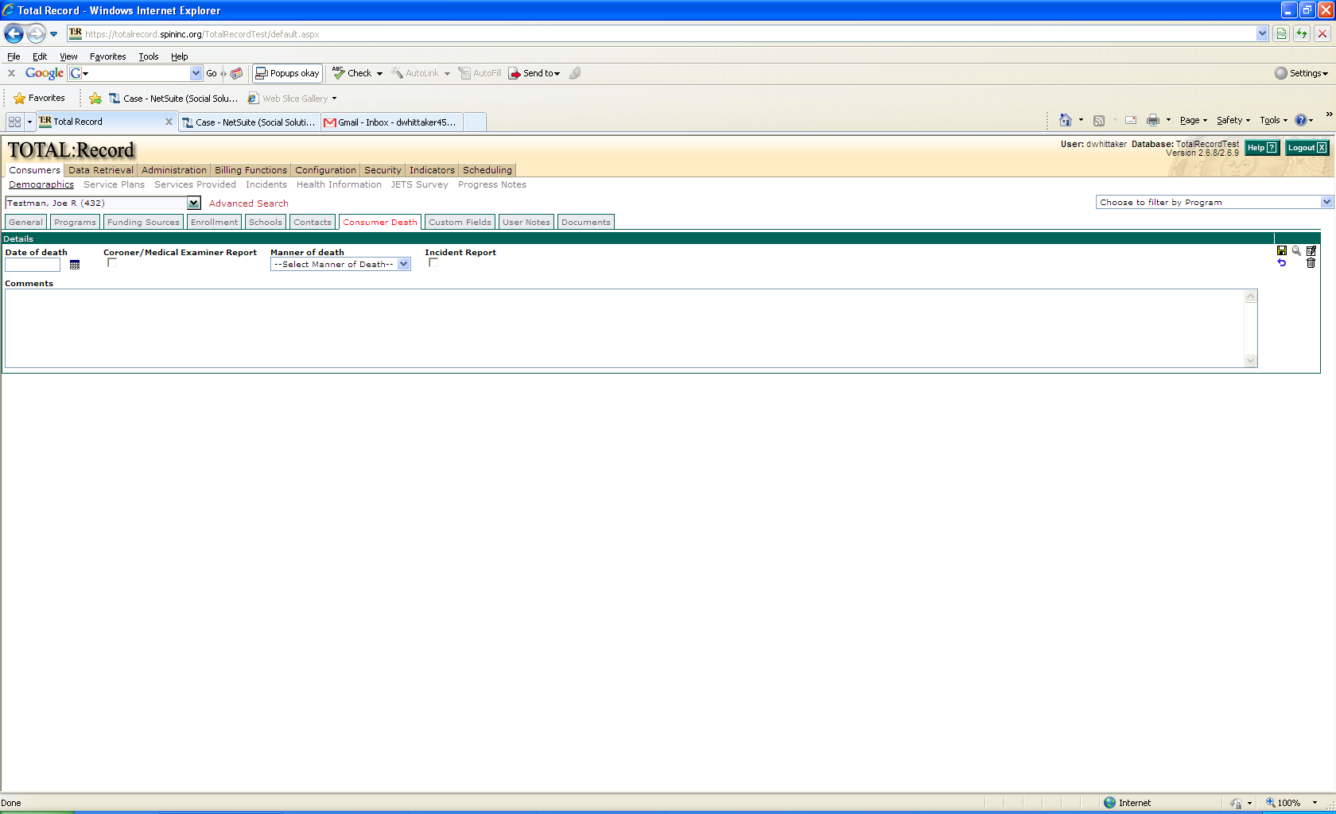

**Add New Date of Death**

1. To add a new date of death you must go to the **Consumer Death** sub-tab. This is located on the **Demographics** link in the **Consumers** tab.
2. Once on the **Consumer Death** sub – tab you can now enter the date of death in the **Date of Death** field.
3. Next check off whether or not you have a **Cororner/Medical Examiners Report**
4. Now from the drop down select the **Manner of death**.

*Note: By adding or changing values in the* ***Manner of Death*** *drop down located in the* ***Dropdowns*** *link in the* ***Configuration*** *tab you can change the list of available manners of death.*

1. Next check off if you have an **Incident Report**.
2. Once you have filled out all of that you can now enter in any comments.
3. When you are done click the save icon.

**Modifying/Deleting Date of Death information**

1. To add a new date of death you must go to the **Consumer Death** sub-tab. This is located on the **Demographics** link in the **Consumers** tab.
2. Once there click the edit icon.
3. You should now have the rights to edit all of the fields in the **Consumers Death** sub-tab.
4. Once you have finished editing click the save button.
5. To delete a date of death click on the delete button.